K-Beach Coastal Stream
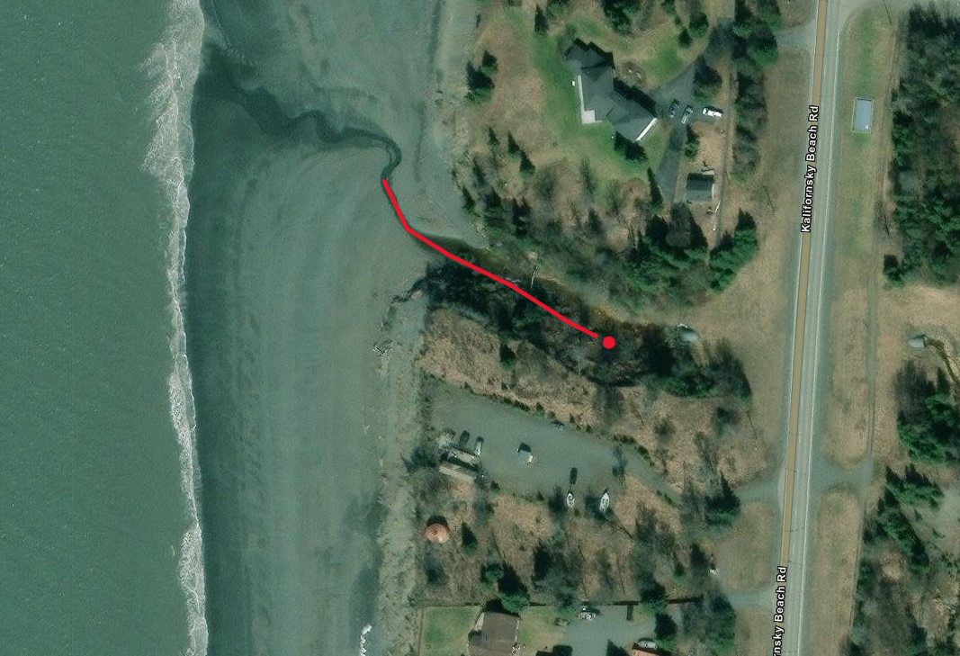
Upper extent of Coho
60.4736 N, -151.2806 W

